Assignment 2 requirements

Project background:
Green World company is a new re-cycling concept organization based in Hong Kong which established on Jan 1, 2026.
Green World’s products were donated by the public and sold to the public with discounted price.
So far, customers need to visit the physical stores to purchase the products.
Green World would like to sell products online and would like to set up an E-shop/website to display their company’s information, product information and be able to sell products online if possible.

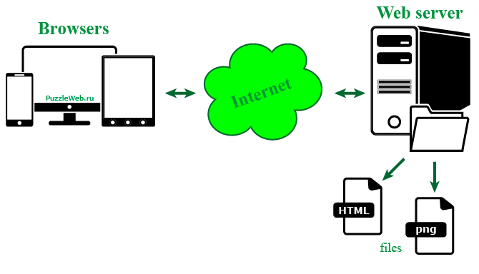

Business requirement(s):
R1: Green World would like to set up a E-shop (website) to display and sell products.
R2: comp7780_home.html (home page) contains heading, company information and footing sections (display company information).
R3: comp7780_product.html (product page) contains heading, company information, product information, and footing sections (display product information).
R5: comp7780_product.html (product page) allows users to place their orders.

IT requirement(s):
ITR1: Set up Node.js web server.
ITR2: Set up MySQL Database to store transaction data.

NOTE: we will have 3 iterations/cycles.
Before we started our first iteration, clients added one additional requirement (R4).

R4: This project allows users to pay for the orders using PayPal.

Note 2: During cycle 2, clients added one more requirement (R6).

R6: The students’ information at the bottom of the web page must be in table format.

